HTML Form Attributes

describes the different attributes for the HTML <form> element.

* **Action Attribute**

The action attribute defines the action to be performed when the form is submitted.

In the example below, the form data is sent to a file called "action_page.php". This file contains a server-side script that handles the form data:

**Example**

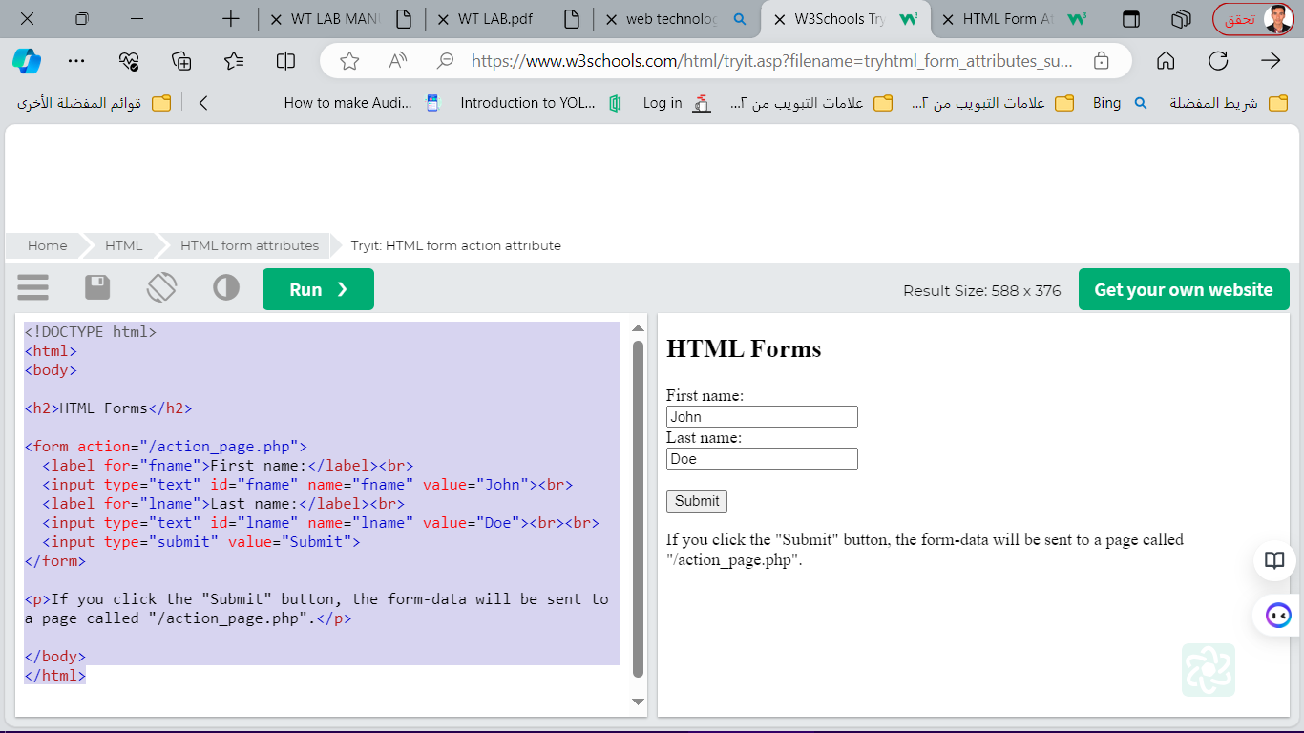On submit, send form data to "action_page.php":

<!DOCTYPE html>

<html>

<body>

<h2>HTML Forms</h2>

<form action="/action_page.php">

<label for="fname">First name:</label><br>

<input type="text" id="fname" name="fname" value="John"><br>

<label for="lname">Last name:</label><br>

<input type="text" id="lname" name="lname" value="Doe"><br><br>

<input type="submit" value="Submit">

</form>

<p>If you click the "Submit" button, the form-data will be sent to a page called "/action_page.php".</p>

</body>

</html>

* **The Target Attribute**

The target attribute specifies where to display the response that is received after submitting the form.

The target attribute can have one of the following values:

|  |  |
| --- | --- |
| Value | Description |
| _blank | The response is displayed in a new window or tab |
| _self | The response is displayed in the current window |
| _parent | The response is displayed in the parent frame |
| _top | The response is displayed in the full body of the window |
| framename | The response is displayed in a named iframe |

<!DOCTYPE html>

<html>

<body>

<h2>The form target attribute</h2>

<p>When submitting this form, the result will be opened in a new browser tab:</p>

<form action="/action_page.php" target="_blank">

<label for="fname">First name:</label><br>

<input type="text" id="fname" name="fname" value="John"><br>

<label for="lname">Last name:</label><br>

<input type="text" id="lname" name="lname" value="Doe"><br><br>

<input type="submit" value="Submit"></form>

The Method Attribute

The method attribute specifies the HTTP method to be used when submitting the form data.

The form-data can be sent as URL variables (with method="get") or as HTTP post transaction (with method="post").

The default HTTP method when submitting form data is GET.

<!DOCTYPE html>

<html>

<body>

<h2>The method Attribute</h2>

<p>This form will be submitted using the GET method:</p>

<form action="/action_page.php" target="_blank" method="get">

<label for="fname">First name:</label><br>

<input type="text" id="fname" name="fname" value="John"><br>

<label for="lname">Last name:</label><br>

<input type="text" id="lname" name="lname" value="Doe"><br><br>

<input type="submit" value="Submit">

</form>

<p>After you submit, notice that the form values is visible in the address bar of the new browser tab.</p>

</body>

</html>

* **The Autocomplete Attribute**

The autocomplete attribute specifies whether a form should have autocomplete on or off.

When autocomplete is on, the browser automatically complete values based on values that the user has entered before.

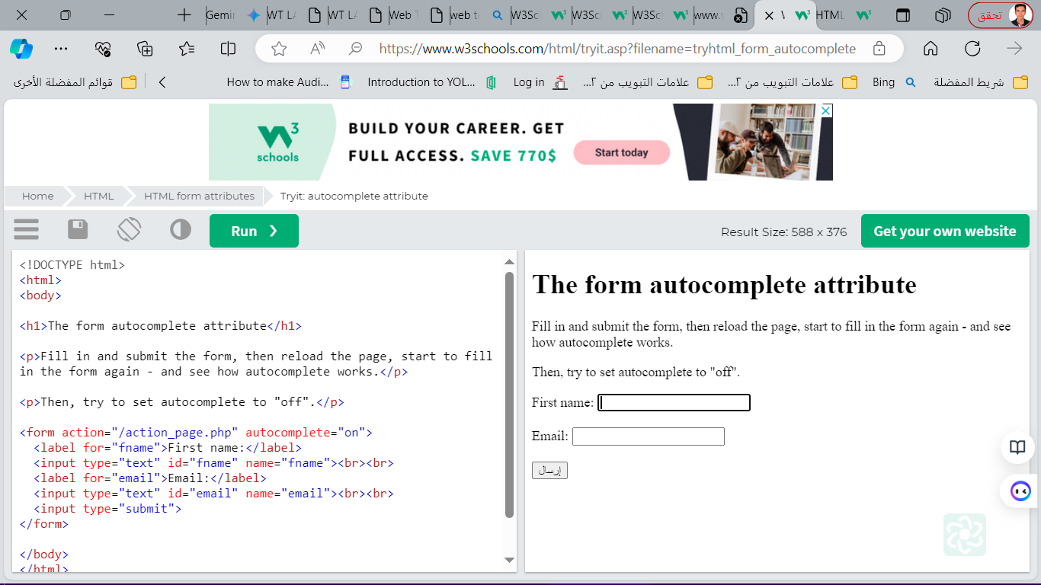

* **The Novalidate Attribute**

The novalidate attribute is a boolean attribute.

When present, it specifies that the form-data (input) should not be validated when submitted.

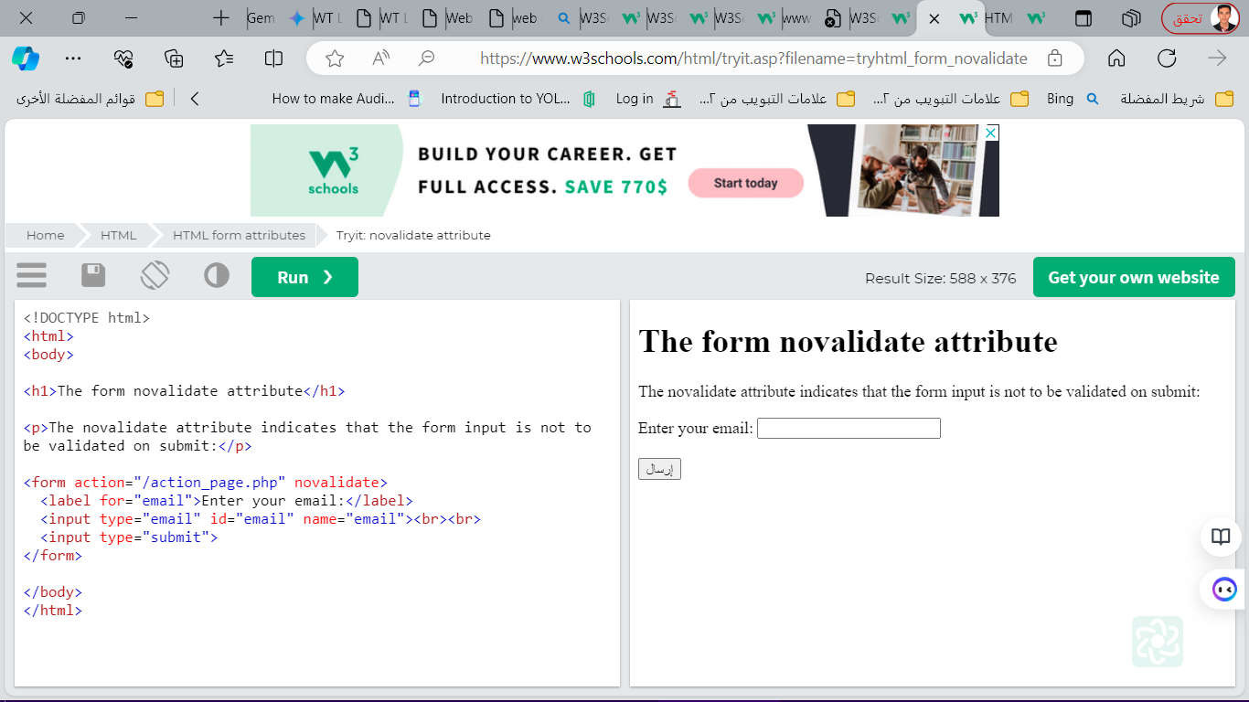

* **List of All <form> Attributes**

|  |  |
| --- | --- |
| Attribute | Description |
| [accept-charset](https://www.w3schools.com/tags/att_form_accept_charset.asp) | Specifies the character encodings used for form submission |
| [action](https://www.w3schools.com/tags/att_form_action.asp) | Specifies where to send the form-data when a form is submitted |
| [autocomplete](https://www.w3schools.com/tags/att_form_autocomplete.asp) | Specifies whether a form should have autocomplete on or off |
| [enctype](https://www.w3schools.com/tags/att_form_enctype.asp) | Specifies how the form-data should be encoded when submitting it to the server (only for method="post") |
| [method](https://www.w3schools.com/tags/att_form_method.asp) | Specifies the HTTP method to use when sending form-data |
| [name](https://www.w3schools.com/tags/att_form_name.asp) | Specifies the name of the form |
| [novalidate](https://www.w3schools.com/tags/att_form_novalidate.asp) | Specifies that the form should not be validated when submitted |
| [rel](https://www.w3schools.com/tags/att_form_rel.asp) | Specifies the relationship between a linked resource and the current document |
| [target](https://www.w3schools.com/tags/att_form_target.asp) | Specifies where to display the response that is received after submitting the form |

**HTML Form Elements**

The HTML <form> element can contain one or more of the following form elements:

<input>

<label>

<select>

<textarea>

<button>

<fieldset>

<legend>

<datalist>

<output>

<option>

<optgroup>

* **The <input> Element**

One of the most used form elements is the <input> element.

The <input> element can be displayed in several ways, depending on the type attribute.

Example

<label for="fname">First name:</label>  
<input type="text" id="fname" name="fname">

* **The <label> Element**

The <label> element defines a label for several form elements.

The <label> element is useful for screen-reader users, because the screen-reader will read out loud the label when the user focus on the input element.

The for attribute of the <label> tag should be equal to the id attribute of the <input> element to bind them together.

* **The <select> Element**

The <select> element defines a drop-down list:

<label for="cars">Choose a car:</label>  
<select id="cars" name="cars">  
  <option value="volvo">Volvo</option>  
  <option value="saab">Saab</option>  
  <option value="fiat">Fiat</option>  
  <option value="audi">Audi</option>  
</select>

The <option> element defines an option that can be selected.

By default, the first item in the drop-down list is selected.

To define a pre-selected option, add the selected attribute to the option:

<option value="fiat" selected>Fiat</option>

* **Visible Values:**

Use the size attribute to specify the number of visible values:

Example

<label for="cars">Choose a car:</label>  
<select id="cars" name="cars" size="3">  
  <option value="volvo">Volvo</option>  
  <option value="saab">Saab</option>  
  <option value="fiat">Fiat</option>  
  <option value="audi">Audi</option>  
</select>

* **Allow Multiple Selections:**

Use the multiple attribute to allow the user to select more than one value:

<label for="cars">Choose a car:</label>  
<select id="cars" name="cars" size="4" multiple>  
  <option value="volvo">Volvo</option>  
  <option value="saab">Saab</option>  
  <option value="fiat">Fiat</option>  
  <option value="audi">Audi</option>  
</select>

* **The <textarea> Element**

The <textarea> element defines a multi-line input field (a text area):

<textarea name="message" rows="10" cols="30">  
The cat was playing in the garden.

</textarea>

The rows attribute specifies the visible number of lines in a text area.

The cols attribute specifies the visible width of a text area.

This is how the HTML code above will be displayed in a browser:



You can also define the size of the text area by using CSS:

<textarea name="message" style="width:200px; height:600px;">  
The cat was playing in the garden.

</textarea>

* **The <button> Element**

The <button> element defines a clickable button:

<button type="button" onclick="alert('Hello World!')">Click Me!</button>

This is how the HTML code above will be displayed in a browser:

**Note**: Always specify the type attribute for the button element. Different browsers may use different default types for the button element.

* **The <fieldset> and <legend> Elements**

The <fieldset> element is used to group related data in a form.

The <legend> element defines a caption for the <fieldset> element.

<form action="/action_page.php">  
  <fieldset>  
    <legend>Personalia:</legend>  
    <label for="fname">First name:</label><br>  
    <input type="text" id="fname" name="fname" value="John"><br>  
    <label for="lname">Last name:</label><br>  
    <input type="text" id="lname" name="lname" value="Doe"><br><br>  
    <input type="submit" value="Submit">  
  </fieldset>  
</form>

This is how the HTML code above will be displayed in a browser:

Personalia:First name:  
  
Last name:  
  
  


* **The <datalist> Element**

The <datalist> element specifies a list of pre-defined options for an <input> element.

Users will see a drop-down list of the pre-defined options as they input data.

The list attribute of the <input> element, must refer to the id attribute of the <datalist> element.

Example

<form action="/action_page.php">  
  <input list="browsers">  
  <datalist id="browsers">  
    <option value="Edge">    <option value="Firefox">  
    <option value="Chrome">  
   <option value="Opera">  
    <option value="Safari">  
  </datalist>  
</form

* **The <output> Element**

The <output> element represents the result of a calculation (like one performed by a script).

Perform a calculation and show the result in an <output> element:

<form action="/action_page.php"  
  oninput="x.value=parseInt(a.value)+parseInt(b.value)">  
  0  
  <input type="range"  id="a" name="a" value="50">  
  100 +  
  <input type="number" id="b" name="b" value="50">  
  =  
  <output name="x" for="a b"></output>  
  <br><br>  
  <input type="submit">  
</form>

HTML Form Elements

|  |  |
| --- | --- |
| Tag | Description |
| [<form>](https://www.w3schools.com/tags/tag_form.asp) | Defines an HTML form for user input |
| [<input>](https://www.w3schools.com/tags/tag_input.asp) | Defines an input control |
| [<textarea>](https://www.w3schools.com/tags/tag_textarea.asp) | Defines a multiline input control (text area) |
| [<label>](https://www.w3schools.com/tags/tag_label.asp) | Defines a label for an <input> element |
| [<fieldset>](https://www.w3schools.com/tags/tag_fieldset.asp) | Groups related elements in a form |
| [<legend>](https://www.w3schools.com/tags/tag_legend.asp) | Defines a caption for a <fieldset> element |
| [<select>](https://www.w3schools.com/tags/tag_select.asp) | Defines a drop-down list |
| [<optgroup>](https://www.w3schools.com/tags/tag_optgroup.asp) | Defines a group of related options in a drop-down list |
| [<option>](https://www.w3schools.com/tags/tag_option.asp) | Defines an option in a drop-down list |
| [<button>](https://www.w3schools.com/tags/tag_button.asp) | Defines a clickable button |
| [<datalist>](https://www.w3schools.com/tags/tag_datalist.asp) | Specifies a list of pre-defined options for input controls |
| [<output>](https://www.w3schools.com/tags/tag_output.asp) | Defines the result of a calculation |